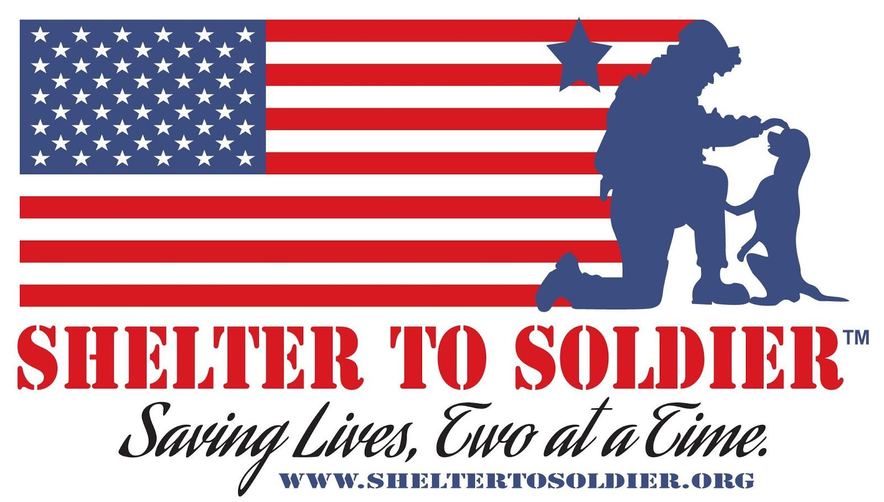
Shelter to Soldier 1st Annual
Saving Lives One Swing at a Time Golf Tournament
Donation Request

Shelter to Soldier is hosting our 1st Annual Saving Lives One Swing at a Time Golf Tournament on Thursday, April 23rd 2020 at the Swinging Hills Golf Resort at Sycuan. Our mission is to adopt dogs from local shelters and train them to become psychiatric service dogs for post-9/11 combat veterans suffering from Post Traumatic Stress (PTS), Traumatic Brain Injury (TBI) and other injuries associated with traumatic service experiences. Donations to our event will be prominently displayed to an affluent and savvy audience of approximately 144 golfers, and will contribute to our fundraising efforts for the event where 100% of net proceeds will directly benefit our service dog training program and expansion of our support services for veterans.

Shelter to Soldier’s 1st Annual Golf Tournament will be a critical component of our annual fundraising efforts and will contribute significantly to the impact we make in the dog rescue and veteran communities in Southern California. Headquartered in San Diego and in operation since 2012, Shelter to Soldier has successfully trained and placed 25 dogs in working service and one emotional support dog (ESD) with veteran handlers, and our goal is to place 4 more this year. On average, we have 24 dogs in our training program at all times. We hope to grow our number of annual graduations with more funding. With the support of community partners, our elite service dog training program continues to save the lives of dogs with an otherwise uncertain future and the lives of veterans from potential suicide ideation and risk.

Thank you for your consideration, we hope that you will join our efforts with your contribution to our newest and most exciting fundraiser!

Nonprofit ID: 46-0906020
Website: www.sheltertosoldier.org
Social: @sheltertosoldier (Instagram and Facebook), @shelter2soldier (Twitter)
Contact: Kyrié Bloem kyrie@sheltertosoldier.org : Co- Founder/ Vice President
Debbie Fresca Debbie@sheltertosoldier.org : Administrative Assistant
Donation Form:
Donor’s Company Name:______________________________________________
Contact Person:_____________________________________________________
Email:_____________________________________________________________
Address:___________________________________________________________
Phone #: __________________________________________________________
Item(s) Donated: ____________________________________________________
Special Instructions: _________________________________________________
Estimated Value or Cost: _____________________________________________
*Please feel free to send your company info/business cards to be displayed at the event!
Shelter to Soldier thanks you for your donation!
For questions please contact:
Kyrié Bloem
Cofounder & Vice President, Shelter to Soldier
855-287-8659 / kyrie@sheltertosoldier.org
www.sheltertosoldier.org

Please return form via fax to 858-225-7173 or scan and email to Debbie@sheltertosoldier.org
Shelter to Soldier is a 501c3 non-profit organization that rescues shelter dogs and trains them to be psychiatric service companions for veterans. Tax ID # 46-0906020.

